**LAB 2 Report**

Student number: 12161762

Name: LEE YEONG JUN

**#1**

<Code/Result>

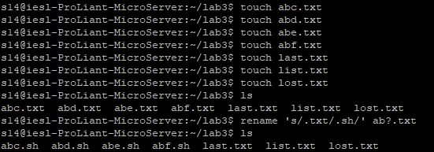

**#2**

<Code>

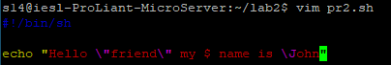

<Result>



**#3**

<Code>

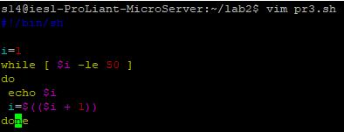

<Result>

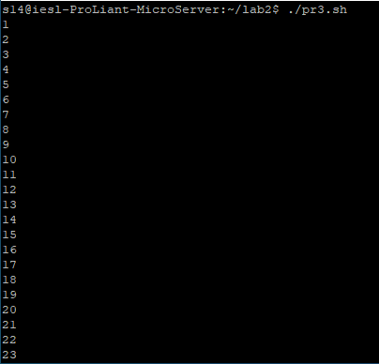

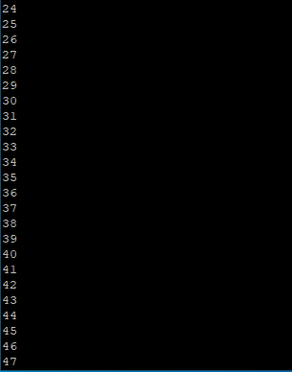



**#4**

<Code>

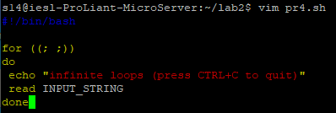

<Result>

